Curriculum Vitae

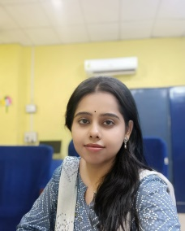

* **Name**: Debarati Mondal
* **Father's name**: Partha Sarathi Mondal
* **Mother's name**: Sukla Mondal
* **Date of birth**: 19th April, 1993
* **Permanent address**: “Amar Manjil”, Rampur
  + **Post+Dist:** Bankura
  + **Pin**: 722101
* **Email**: [debaratimondal929@gmail.com](mailto:debaratimondal929@gmail.com)
* **Mobile Number**: 9474928944
* **Designation**: SACT I
* **Name of the college**: Bankura Sammilani College
* **Date of joining**: 10/07/2019
* **Nationality**: Indian
* **Sex**: Female
* **Academic Details:**

|  |  |  |  |  |
| --- | --- | --- | --- | --- |
| **Sl.No** | **Exam Passed** | **University/Institution** | **Year of Passing** | **Subject** |
| 1 | B.A. | Burdwan University | 2014 | English |
| 2 | M.A. | Burdwan University | 2016 | English |
| 3 | SET | West Bengal College Service Commission | 2018 | English |
| 4 | NET | National Testing Agency | 2022 | English |

* **Seminar Presentation:**

|  |  |  |  |  |
| --- | --- | --- | --- | --- |
| **Sl.**  **No** | **Name of the Paper** | **Name of the**  **Institution/Journal** | **Type of**  **Seminar** | **Date** |
| 1 | ‘John laughs at me , ofcourse, but one expects that in marriage’: The Effect of Psychological Damage on Feminine Psyche: Comaparative Study of *The* *Yellow Wallpaper* and *Cry the Peacock* | New Literaria: *An International Journal of Interdisciplinary*  *Studies in Humanities* | International | 24th  October, 2021 |

|  |  |  |
| --- | --- | --- |
| * **Areas of Teaching** | **:** | British poetry and Drama Indian Writing in English Modern European Drama  Indian Diaspora  Detective Fiction  Literary theory and criticism |

Debarati Mondal